**WEEK 7-9**

**DOCUMENTATION**

Presented to the Faculty of the College of Arts, Sciences, and Technology

**OCCIDENTAL MINDORO STATE COLLEGE**

Sablayan Campus

In Partial Fulfillment of the Requirements for the Subject

**COMPUTER PROGRAMMING**

**Advincula, Regine P.**

**Borja, Jhontolip C.**

**Cartagena, Prince Ceasar G.**

**Castillo, Alpha Grace A.**

**Clarito, Marco Paulo M.**

**De Lara, Clan Derick Z.**

**Ebon, Richard G.**

**Elinon, Russel John P.**

**Estrada, Emberlyn Hope E.**

**Gamino, Sonny Boy D.**

**Jugo, John Leoanard**

**Labiano, Harvey Philip B.**

**Matandag, Juralyn S.**

**Mengabon, Rowela**

**Ordenes, Jawe Mac Sheen J.**

**Quiambao, John Albert N.**

**Ramos, Aaron G.**

**Roja, Myca P.**

**Sebastian, Renz Aljohn Z.**

**Tulaylay, Mark Joel B.**

**Malla, Jinky**

**Duron, fabrice**

**DOCUMENTATION**

SEPTEMBER 19, 2023

**DISCUSSION**

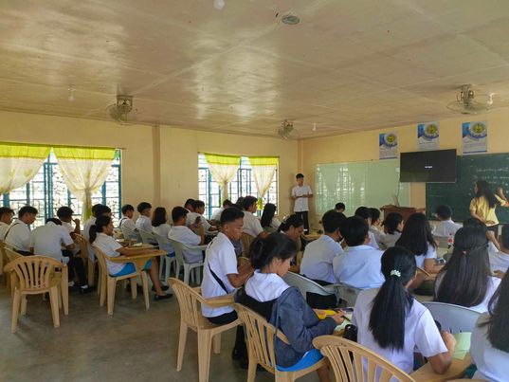Size: 3R (3.5x5 inches)

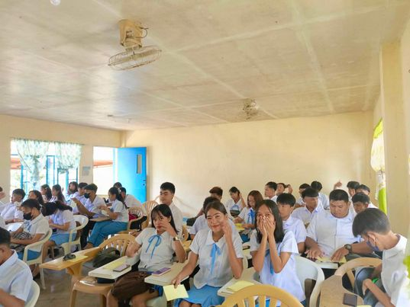Photo Size: 3R (3.5x5 inches)

**DOCUMENTATION**

**AUGUST 14, 2023**

The picture were captured during discussion on the subject Computer Programming where each student stimulated active engagement and participation. On September 19, 2023, the BSIT 1-B students encouraged to interact with the material, ask questions, seek assistance, and apply what they've learned.

**DOCUMENTATION**

SEPTEMBER 21, 2023

**LABORATORY**

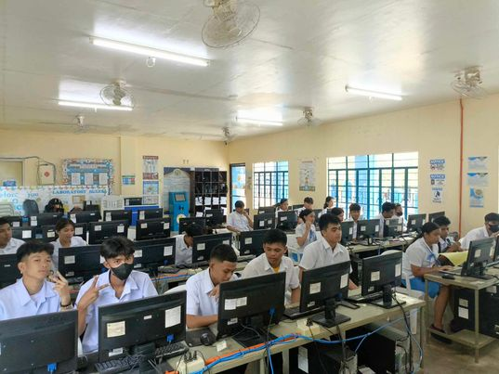

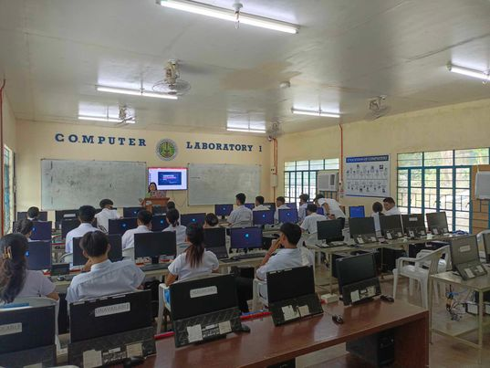

The pictures were captured during Laboratory Activity on the subject Computer Programming. On September 21, 2023, the BSIT 1-B students were allowed to apply the theoretical concepts they have learned in lectures and textbooks to real-world situations.

**DOCUMENTATION**

SEPTEMBER 26, 2023

**DISCUSSION**

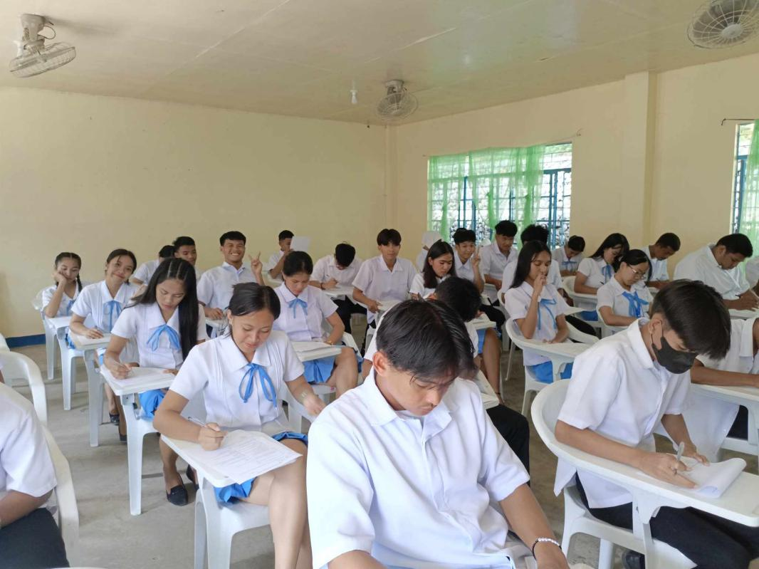Size: 3R (3.5x5 inches)

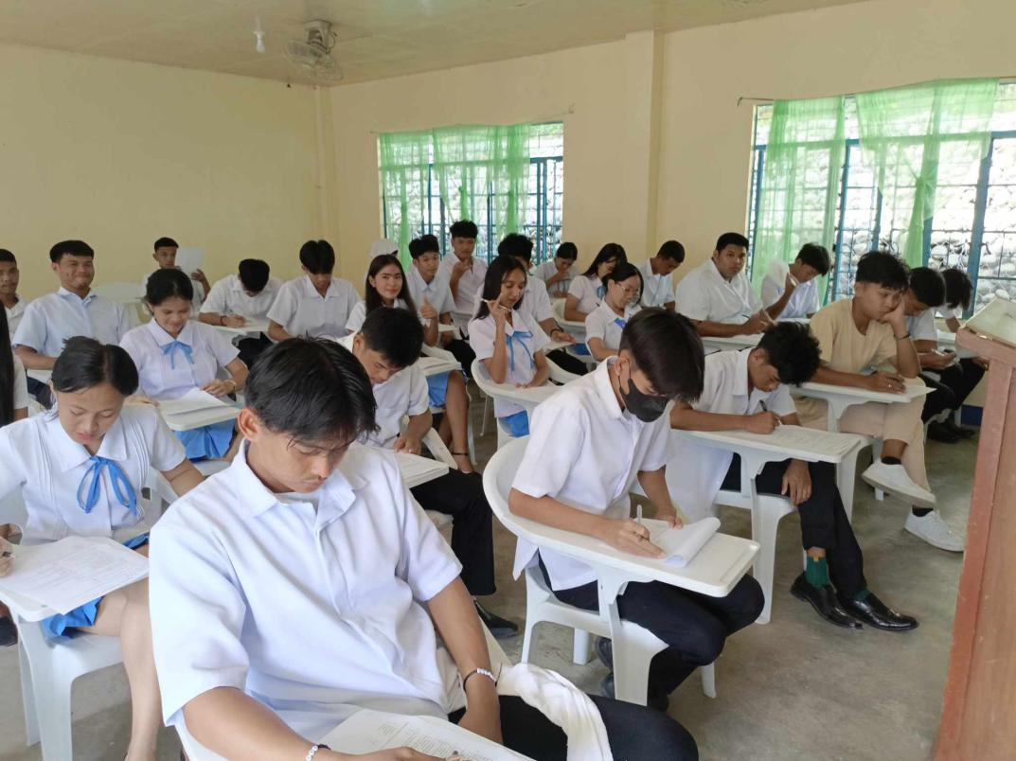Photo Size: 3R (3.5x5 inches)

**DOCUMENTATION**

**AUGUST 14, 2023**

The pictures were captured during long quiz on the subject Computer Programming. On September 26, 2023, the BSIT 1-B students were allowed to apply the theoretical concepts and cognitive learning they have learned in lectures and textbooks.

**DOCUMENTATION**

SEPTEMBER 28, 2023

**LABORATORY**

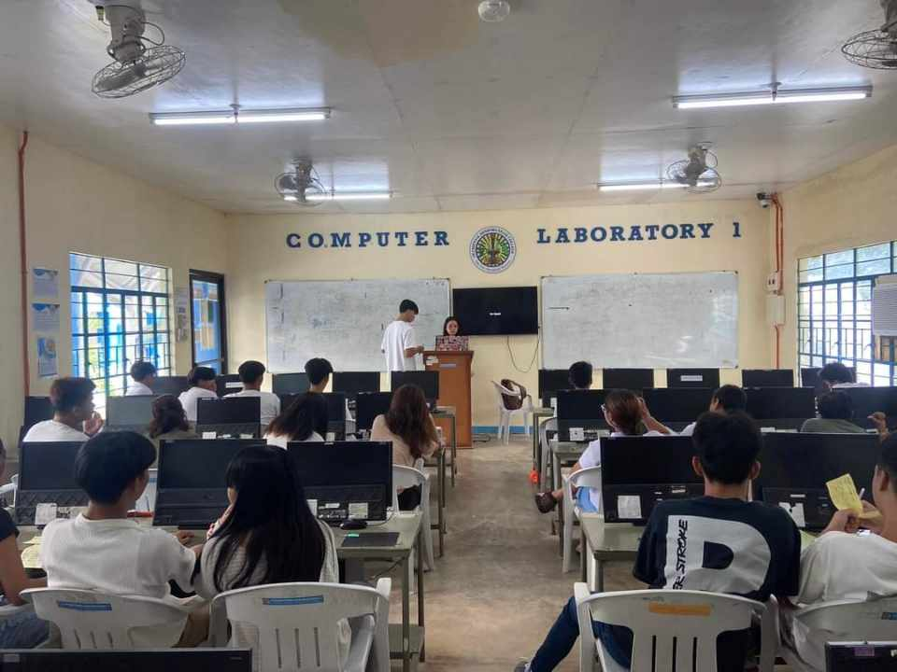

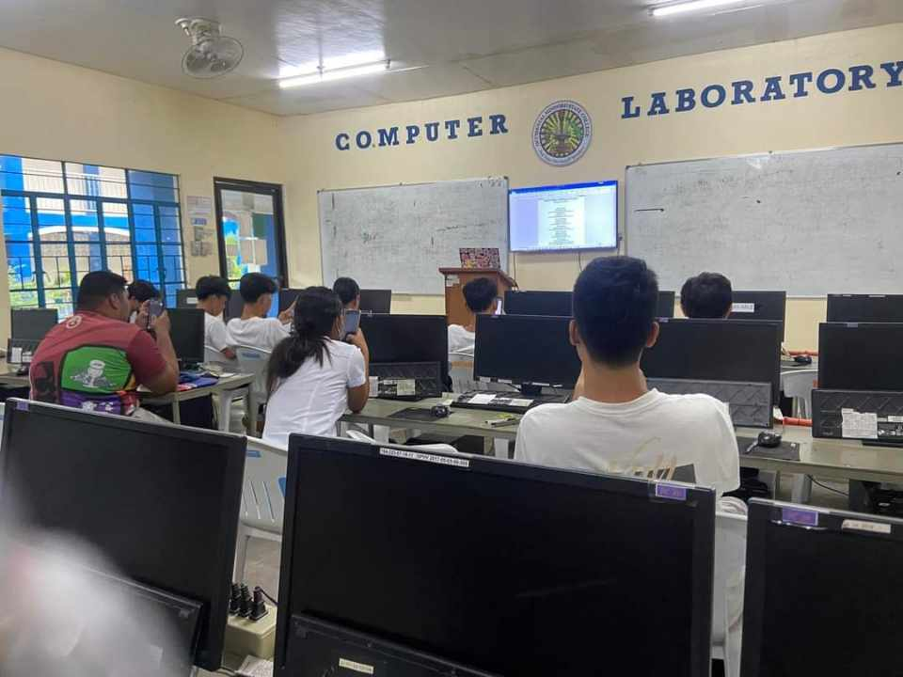

The pictures were captured during our laboratory on the subject Computer Programming. On September 28, 2023, the BSIT 1-B students were allowed to apply the concept and strategies they have learned in lectures and textbooks.

**DOCUMENTATION**

OCTOBER 3, 2023

**MIDTERM EXAMINATION**

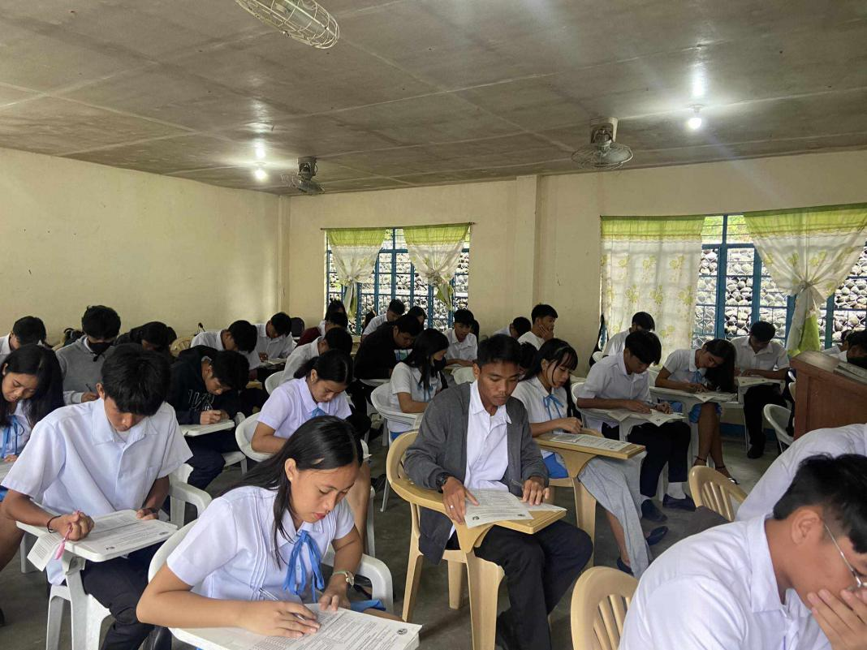

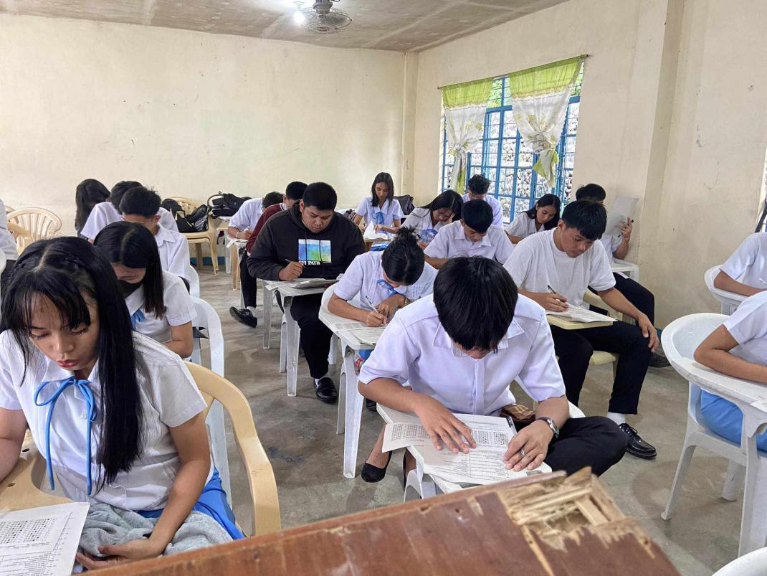

The pictures were captured during Examination on the subject Computer Programming. On October 03, 2023, the BSIT 1-B students were allowed to apply all lesson they have learned in lectures and textbooks.

**DOCUMENTATION**

OCTOBER 5, 2023

**LABORATORY**

No class.

Since our midterm exam has done. Our instructor decided not to have class today.